Hostname: mysql-gatorevents-db.ufgatorevents.com

Database: gatorEvents_DB

username: gatorevents_db

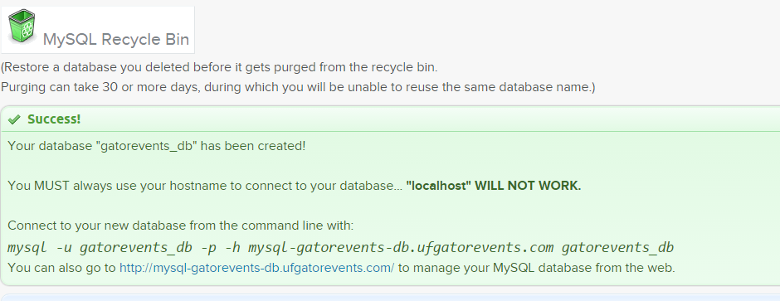

Your database "gatorevents_db" has been created!

You MUST always use your hostname to connect to your database... "localhost" WILL NOT WORK.

Connect to your new database from the command line with:

mysql -u gatorevents_db -p -h mysql-gatorevents-db.ufgatorevents.com gatorevents_db

You can also go to http://mysql-gatorevents-db.ufgatorevents.com/ to manage your MySQL database from the web.